Git Commands

* Check version of git



* Clone the repository on local machine

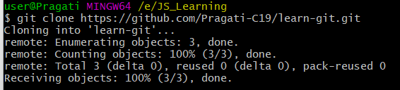

* Change directory

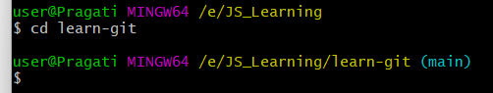

* List everything in the directory

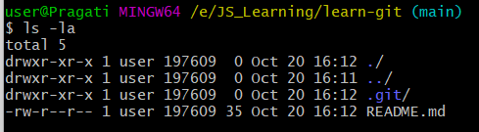

* Show all of the files that were updated or created or deleted, but haven't been saved in a commit yet.

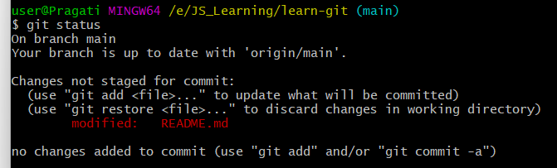

* Track your files

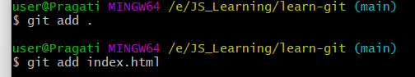

* Save your files in git and give a comments

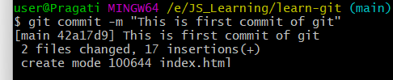

* Upload git commit to github

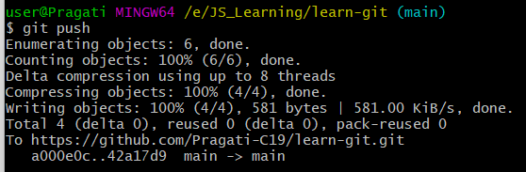

* Connect your local machine to github account using SSH (Secure Shell) key
* If we already have a folder in local machine and want to push that folder on github then use:

git remote add origin (paste the link copied to clone the repo)

* Get list of branches



* Create new branch and switch branch

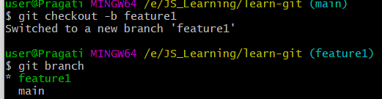

* Check what changes have been made in new branch before merge

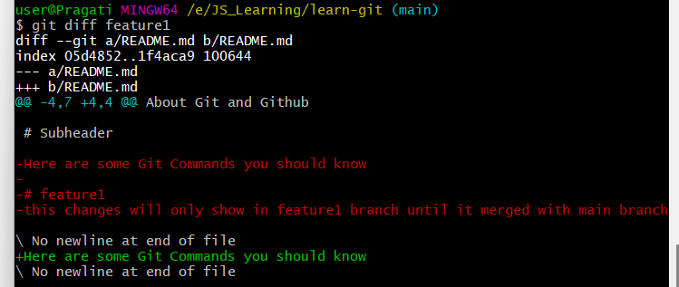

* Merge branch to the main branch

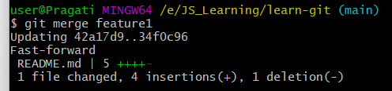

* At the time of git push feature branch if you get error do this

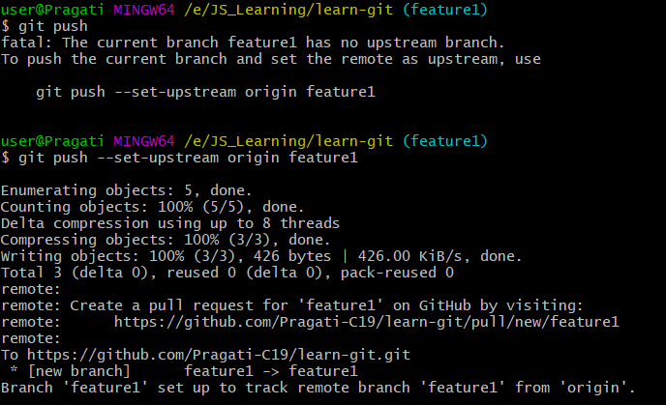

* Download changes from github

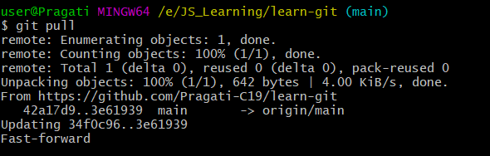

* Delete the branch



* Undoing the changes in git

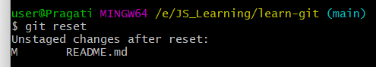

* Get pointer to the last commit

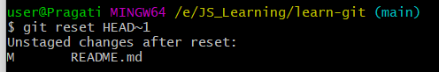

* Check which author working on which file folder or branch

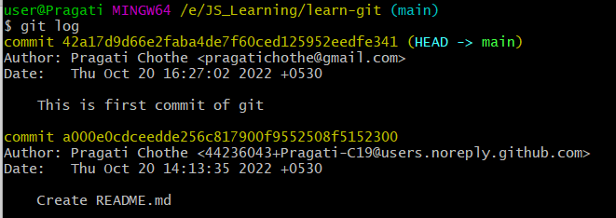

Advance Commands

* Check latest list of commits at a time

git log –oneline

* Select specific commits to change or update

git rebase -i HEAD~3 (for 3 commits)

* Some commands to edit or change commits from the list :

